

MATATUCONNECT: A SMART FEEDBACK, PAYMENT, AND OCCUPANCY AWARENESS PLATFORM FOR INFORMAL PUBLIC TRANSPORT

https://www.canva.com/design/DAG-a-TlFEo/z01CFs337lFWrKKbDMQ3OQ/view?utm_content=DAG-a-TlFEo&utm_campaign=designshare&utm_medium=link2&utm_source=uniquelinks&utlId=hbdd9688640

A Project Proposal Submitted in Partial Fulfillment of the Requirements for the Award of Bachelor of Science in Software Engineering.

DECLARATION
We declare that this proposal is our original work and has not been submitted for academic evaluation in any other institution. Information borrowed from other sources has been acknowledged accordingly through proper citations. Examples of personal details used in the text, such as names, items, or scenarios, are fictional and are only used for academic illustration.

NGUGI PETER MURIITHI PA106/G/17476/22
WAHOME WILLIAM WANGOMBE PA106/G/17525/22
BONFACE MAMBOLEO ONDIEKI PA106/G/15329/21
NDUNGU BEN MBURU PA106/G/17462/22
NDUNGU PHINEAS PA106/G/17490/22
ABSTRACT

Kenya’s informal public transport system, particularly matatus, plays a critical role in urban mobility but continues to operate with minimal digital integration. Passengers face challenges such as lack of structured feedback channels, cash-based fare payments, overcrowding, and poor service accountability. MatatuConnect is a smart digital platform designed to address these challenges by integrating passenger feedback, simulated mobile fare payments, and near real-time occupancy awareness into a single system. The proposed system allows passengers to submit complaints or compliments linked to specific vehicles and routes, simulate fare payments using the M-Pesa Daraja API in sandbox mode, and view occupancy status updated by drivers or conductors. Built using modern web technologies including TypeScript, Node.js, and a relational database, the system also integrates WhatsApp notifications for confirmations and alerts. Although payments and occupancy tracking are simulated for academic feasibility, MatatuConnect demonstrates a scalable and practical approach to digitizing informal public transport. The project aims to enhance transparency, efficiency, and user experience while providing a foundation for future real-world deployment.

PRESENTED BY:

Name:
Signature
Name:
Signature
Name:
Signature
Name:
Signature
Name:
Signature

Supervisor
Name:
Signature

LIST OF FIGURES
Figure 3.1: System architecture diagram 9
Figure 3.2: Agile Development Cycle 10

TABLE OF CONTENTS
- INTRODUCTION
  - Background of the Study 6
  - Problem Statement 6
  - Research Objectives 7
  - Significance of the Study 7
  - Scope of the Study ………………………………………………………………………………………………………7
- LITERATURE

  - Introduction 8
  - Review of Related Systems 8
  - Research Gaps 8
  - Conceptual Framework 8

- METHODOLOGY

  - Research Design 9
  - System Development Methodology 9
  - Tools and Technologies 9
  - Data Collection 9
  - System Architecture 9
  - Testing 10

- REFERENCES 10

- APPENDICES
  - Project Work Plan (Gantt Chart) 11
  - Group roles 11

ABBREVIATIONS & ACRONYMS
SDG – Sustainable Development Goal
SMS – Short Message Service
UX – User Experience
DB – Database
UI – User Interface
API – Application Programming Interface

LIST OF TABLES
Table 1: Project Work Plan (Gantt Chart) 19

CHAPTER ONE: INTRODUCTION

1.1 Background of the Study
Public transportation in Kenya is dominated by matatus, which serve millions of commuters daily. Despite their importance, matatu operations remain largely informal, relying on cash payments, verbal communication, and unstructured service delivery. This informality has resulted in challenges such as fare disputes, lack of accountability, overcrowding, and limited channels for passengers to report misconduct or commend good service. With the widespread adoption of mobile phones and mobile money services such as M-Pesa, there exists a significant opportunity to introduce digital solutions that enhance efficiency and transparency within the matatu sector. MatatuConnect is proposed as a digital platform that leverages these technologies to improve passenger experience and operational management.
Matatus account for over 70% of urban commuter trips in Nairobi. . Similarly, passengers often board overcrowded vehicles due to lack of real-time occupancy data.

1.2 Problem Statement
The current matatu transport system lacks a unified digital platform for passenger feedback, secure fare payment, and occupancy awareness. Passengers have no reliable way of reporting service issues, fare payments are cash-based and prone to disputes or theft, and commuters often board overcrowded vehicles due to lack of occupancy information. These challenges contribute to poor service quality, inefficiency, and dissatisfaction among users. Without structured data, operators and regulators are also unable to make informed decisions to improve the system.

1.3 Objectives of the Study
General Objective
To design and develop an Integrated digital platform that enhances feedback management, fare payment simulation, and occupancy awareness in the matatu transport system.
Specific Objectives
- To develop a passenger feedback module for submitting complaints and compliments linked to specific matatus and routes.
- To integrate a simulated mobile fare payment system using the M-Pesa Daraja sandbox API.
- To implement a near real-time occupancy reporting feature updated by drivers or conductors.
- To provide WhatsApp notifications for transaction confirmations and service updates.

1.4 Significance of the Study
The proposed system benefits multiple stakeholders. Passengers gain convenience, transparency, and a voice in service improvement. Matatu operators and SACCOs receive structured data that can be used to enhance service quality and accountability. Academically, the project demonstrates practical application of full-stack development, API integration, and user-centered system design. Policymakers and regulators may also use insights from the system to support transport digitization initiatives
1.5 Scope of the Study
The project focuses on the development of a prototype web/mobile platform with feedback submission, payment simulation, occupancy reporting, and notification features. Real monetary transactions, GPS tracking, and automated sensor-based occupancy detection are excluded. The system is intended for academic demonstration and pilot-scale testing.

CHAPTER TWO: LITERATURE REVIEW

2. 2.1 Introduction
This chapter reviews existing literature and systems related to digital transport platforms, mobile payments in public transport, and crowd-sourced passenger information systems. The review highlights existing solutions, their strengths and weaknesses, and identifies gaps that MatatuConnect seeks to address.

2.2 Related Literature
1. M-Pesa and Urban Mobility- (World Bank, 2020): Highlights successful use of mobile money in transport but notes limited integration in informal sectors.
2. Digitizing Paratransit (ITDP, 2021): Case studies from Nairobi and Lagos show demand for digital tools but emphasize cost and literacy barriers.
3. Crowd-Sourced Transit Apps (Zhang et al., 2019): Platforms like “Moovit” rely on user reports—validating manual occupancy updates as viable.
4. User Trust in Digital Payments (Omwansa & Sullivan, 2018): Kenyan users trust M-Pesa but require clear feedback (e.g., SMS confirmations).
5. HCI in Low-Resource Setting (Patel et al., 2020): Recommends simple UIs with SMS fallbacks—adopted in this design.

2.3 Research Gaps
Most reviewed systems do not provide an integrated solution combining feedback, payment, and occupancy awareness tailored for informal transport. Additionally, many assume full smartphone penetration and neglect SMS-based alternatives for inclusivity. These gaps justify the development of MatatuConnect.

2.4 Conceptual Framework
Passengers interact with the MatatuConnect system to submit feedback, view occupancy status, and simulate payments. Drivers or conductors update occupancy data, while administrators access dashboards for monitoring and analysis. The system processes inputs and sends notifications via SMS or WhatsApp.

CHAPTER THREE: METHODOLOGY
3.1 Research Design
The project adopts a design and development research approach focused on building and evaluating a functional software prototype.
3.2 System Development Methodology
The Agile software development methodology is used due to its iterative nature and flexibility. Development is divided into sprints covering requirements analysis, system design, frontend development, backend development, API integration, testing, and documentation.
3.3 Tools and Technologies
Frontend: TypeScript
Backend: Node.js with Express
Database: MongoDB
APIs: M-Pesa Daraja (Sandbox), WhatsApp Business API
Version Control: GitHub
3.4 Data Collection
Data is obtained through simulated user interactions, role-based testing by team members, and publicly available route and fare information.
3.5 System Architecture
The system consists of a client interface, backend server, database, and external APIs for payment simulation and notifications.
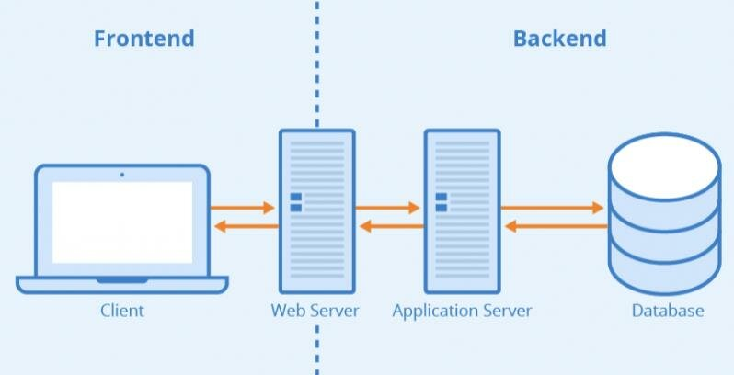
Figure 3.1: System Architecture Diagram

3.6 Testing
Testing includes unit testing, integration testing, usability testing, and performance evaluation to ensure system reliability and correctness.
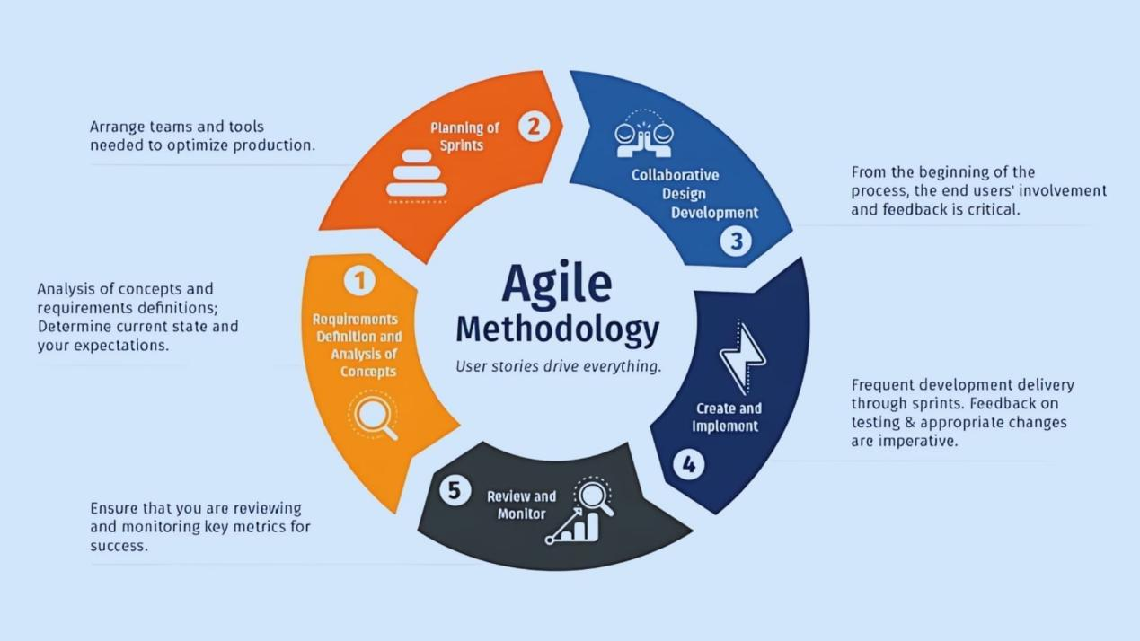
Figure 3.2: Agile methodology diagram

REFERENCES

World Bank (2020). Digital Payments and Urban Mobility. ITDP (2021). Digitizing Paratransit Systems. Safaricom PLC. M-Pesa Daraja API Documentation.

APPENDICES

Appendix 1: Project Work Plan (Gantt Chart)
Below is the simplified Gantt chart for the project timeline (12 Weeks):
Task | Week 1-2 | 3-4 | 5-6 | 7-8 | 9-10 | 11-12
--------------------------------------------------------------------------------
Requirement Gathering | ██████ |
System Design | | ██████
Frontend Development | | ██████
Backend Development | | ████████
Integration & Testing | | ████████
Documentation | | ████
Table 2: Work Plan (Gantt Chart)
Appendix 2: Project group roles
NGUGI PETER MURIITHI PA106/G/17476/22 - Project Lead & Frontend Developer

WAHOME WILLIAM WANGOMBE PA106/G/17525/22- Frontend developer

BONFACE MAMBOLEO ONDIEKI PA106/G/15329/21 - Backend devloper

NDUNGU BEN MBURU PA106/G/17462/22 -Frontend Developer

NDUNGU PHINEAS PA106/G/17490/22 -Backend Devloper , Git & Documentation Co-ordinator

